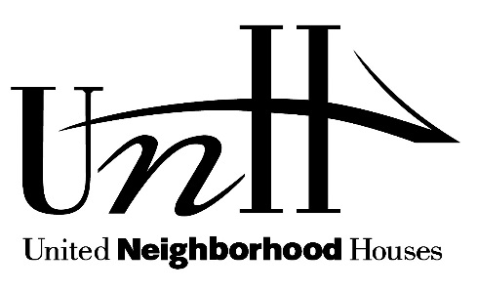 | Press Release – January 30, 2017  Contact: Lindsay Perry  lperry@unhny.org  212-967-0322 x311  Cell: 203-382-4052  Gregory Brender,  gbrender@unhny.org  (917) 992 7372

Statement of Susan Stamler, Executive Director of United Neighborhood Houses
On Mayor de Blasio’s FY 2018 Budget Proposal

New York City’s neighborhoods, like others throughout the country, face fear and uncertainty. It is now more important than ever that New York City’s budget reflect our values by investing in the human services that support our diverse communities. United Neighborhood Houses is thrilled to see new investments in summer jobs for teenagers and Beacon Community Centers. And after working intensively over the past two years to advocate for stable funding for summer camp programs, we are relieved and grateful to see this investment included in the FY 2018 Preliminary Budget. We look forward to working with the Mayor’s administration and the City Council to strengthen the budget over the next several months.

Investing in Youth

UNH applauds Mayor de Blasio for investing in services for youth. By including funds at this point in the budget cycle, youth serving organizations can now design and prepare quality programs for this summer and next school year. UNH is thrilled that the FY 2018 budget proposes to

· Increase Summer Youth Employment Program to serve 65,000 youth;
· Create 10 new Beacon Community Centers; and
· Restore funding for 22,500 middle school summer camp slots.

Human Services Funding

The City took an important step in the right direction by investing in a 2% COLA for staff in human services agencies. However, this investment does not adequately address the financial crisis faced by human services providers- nearly one in five are insolvent and nearly half have zero cash reserves. UNH joined over 200 organizations to call on the Mayor to include a 12% across the board increase for human service providers to address issues such as the underpayment of staff, deficits faced by contracted organizations, and rising occupancy costs of insurance and space.

Adult Literacy

In light of the anti-immigrant rhetoric New Yorkers have been exposed to over the last year and a rise in xenophobic attacks in neighborhoods throughout our city, the City must do all it can to both safeguard the security of immigrant New Yorkers as well as create pathways of opportunity that foster their ability to succeed and thrive. We applaud the Mayor’s commitment to keeping New York a sanctuary city, as well as his expansion of immigrant legal services. However, UNH is deeply disappointed that the Mayor’s budget fails to include ongoing support for ESOL and other adult literacy programs as provided for in FY2017. Last year we heralded the City’s new $12m investment in adult literacy services and are concerned that the Mayor’s budget does not renew these services.

The ability to read, write and communicate in English is essential for immigrants who are supporting their children in school, obtaining good jobs, and participating in the civic life of their communities. The elimination of these funds threatens the chance that thousands of immigrants will learn English. We urge the Mayor to renew and baseline this $12m investment so that the City can establish a stable and robust adult literacy program that promotes immigrant opportunity in the years ahead.

Services for Older Adults
UNH is also disappointed that the preliminary FY 2018 City budget fails to restore more than $13 million in services for older adults that were funded by the City Council in FY 2017. These critical services are trapped in a budget dance and forced to depend on one-year allocations from the City Council to fund core services such as DFTA Core Services Enhancement, NORCs, Elder Abuse Enhancement, Social Adult Day Care, Senior Centers, Programs and Enhancement, 6th Congregate Weekend Meal, Homecare, and Case Management Waitlist. This instability comes at a time when waitlists for case management services continue to rise and glaring disparities in senior center funding leave many neighborhood centers barely surviving. UNH urges the Mayor to baseline funding for cores services for older adults so that the programs they depend upon have the stability to remain strong in order to continue providing vital services for the sometimes vulnerable population.

United Neighborhood Houses (UNH) is New York City’s federation of settlement houses and community centers. Rooted in the history and values of the settlement house movement begun over 100 years ago, UNH promotes and strengthens the neighborhood-based, multi-service approach to improving the lives of New Yorkers in need and the communities in which they live. UNH’s membership includes 37 agencies employing 10,000 people at over 600 sites across the five boroughs to provide high quality services and activities to over 500,000 New Yorkers each year. UNH member agencies provide a broad range of services in a neighborhood based, multi-generational setting, including early childhood education, afterschool, adult literacy, homelessness prevention, services for older adults, and mental health and substance abuse services.

###

