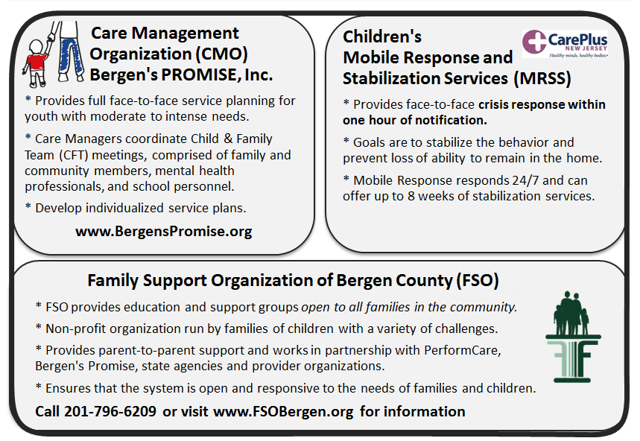


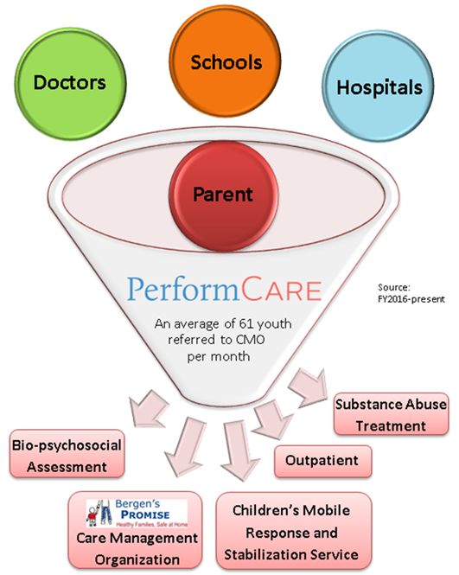
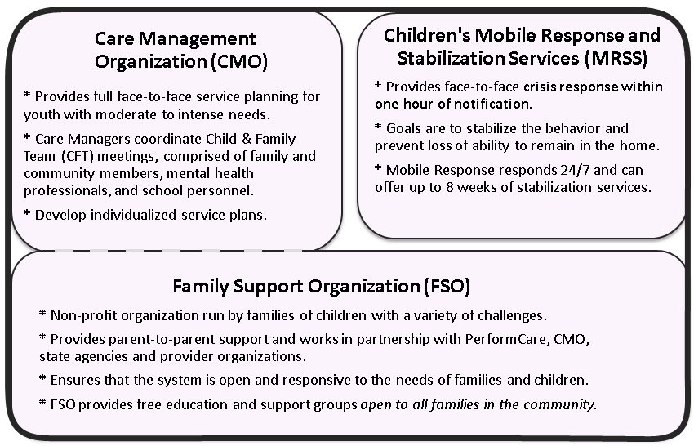

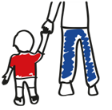
NJ Children’s System of Care
Referral Process
The Children’s System of Care (CSOC) helps youth up to age 21 with emotional, behavioral, developmental, substance and related health challenges. CSOC wraps services and supports that families need in a home and community-based, family-centered environment at no cost to families regardless of income or insurance.

How can YOU assist a family with making the call to PerformCare to access services?
1-877-652-7624
The System Partners in Bergen County

