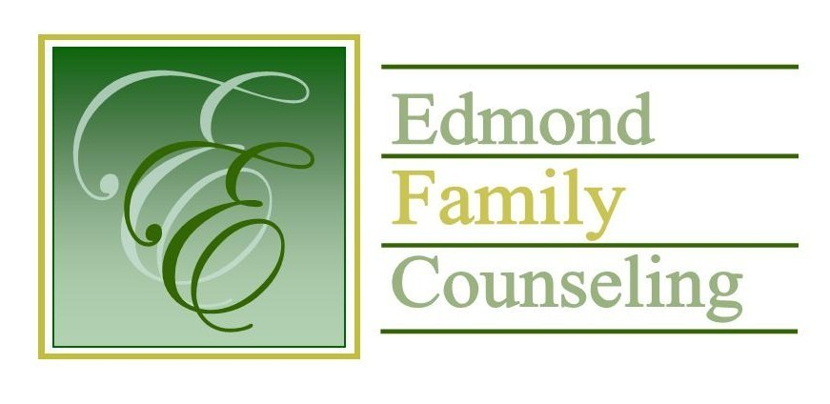
Edmond Family Counseling is committed to strengthening families and our community by championing mental health through prevention, education, and counseling.

October Meeting Agenda
MEETING DATE: October 29, 2019 12:00 to 1:00 pm
Therapist Showcase- Lisa Kadavy

1. Call to Order: President- Chris Budde

2. Consent Agenda: Remember anything in this section can be removed, discussed and voted on separately.
a. September Meeting Minutes
b. September Director’s Report (Summary of Director’s activities since last board mtg.)
c. September Assistant Director’s Report (Summary of Assistant Director’s activities since last board mtg.)
d. September Statistical Report
e. Quarterly Reports for 1st Qtr. of FY’20

3. Old Business
a. Presentation and vote on bid for building renovations
b. Possible consideration and vote on policy and procedure revisions
c. Discussion and vote to approve WSI bid for website migration

4. New Business
a. Possible consideration and vote to enter into executive session under the advisement of attorney Hugh Robert as per title 25 Oklahoma statute 307 (b)(7)
b. Possible consideration and vote to enter regular board session
c. Possible consideration and vote on any motions as a result of executive session
d. Update on meeting with Edmond Municipal Court
e. Update on small group services with Calm Waters

5. Board Resources – Sheila Stinnett
a. Discussion on agency Christmas Party

Legislative focus of the month- Kathy Matthews

6. Committee Reports:
a. Financial Committee
- September Treasurer’s Report
- 1st Qtr. Balance Sheet
- Update on financial audit
- Discussion on current employee leave policy

b. Hope for Families – Chris Budde
c. Fundraising- Sheila Stinnett
d. Public Relations and Be Edmond- Sheila Stinnett
e. Professional Development & Oversight Committee- Bill Hesse

7. New Business- (In accordance with the Open Meeting Act, new business is defined as any matter not known about or which could not have been reasonably foreseen prior to the time of posting the agenda.)

8. Adjournment

Tim Bridges will be providing lunch for October 2019.
Please call 341-3554 & leave a message if you are unable to attend
EFC Board Meeting agenda posted in the EFC lobby October 24, 2019

