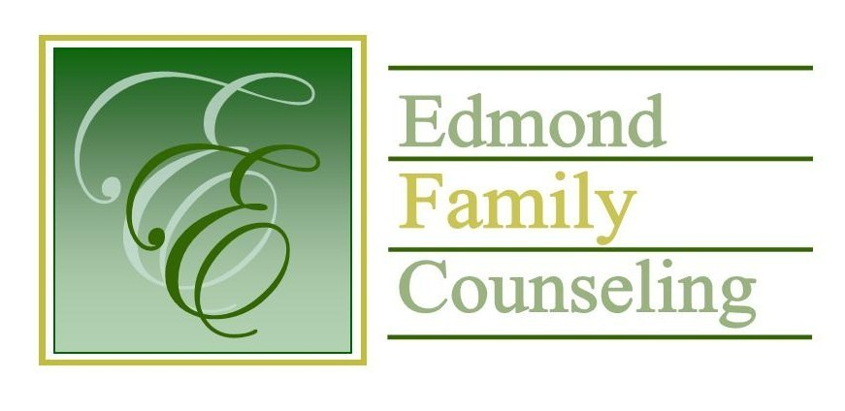
Edmond Family Counseling is committed to strengthening families and our community by championing mental health through prevention, education, and counseling.

November Meeting Agenda
MEETING DATE: Nov 24, 2020 12:00 to 1:00 pm
Therapist Showcase- None

1. Call to Order: President- Chris Budde

2. Consent Agenda: Remember anything in this section can be removed, discussed and voted on separately.
a. September Meeting Minutes
b. September/October Director’s Report (Summary of Director’s activities since last board mtg.)
c. September/October Administrative Manager’s Report (Summary of Administrative Manager’s activities since last board mtg.)
d. September/October Statistical Report
e. Quarterly Reports for 1st Qtr. of FY’21

3. Old Business
a. Possible consideration and vote to approve policy and procedure pertaining to the decommission of hardware and data destruction
b. Update on COVID-19

4. New Business
a. Update on French Family Foundation grant
b. Possible consideration and vote to approve employee health and dental insurance for 2021

5. Board Resources – Sheila Stinnett

Legislative focus of the month- Kathy Matthews

6. Committee Reports:
a. Financial Committee
- Possible consideration and vote to approve September 2020 treasurer’s report
- Possible consideration and vote to approve October 2020 treasurer’s report
- Update on external financial audit

b. Hope for Families – Chris Budde-

c. Fundraising- Sheila Stinnett

d. Public Relations and Be Edmond- Sheila Stinnett

e. Professional Development & Oversight Committee- Bill Hesse

7. New Business- (In accordance with the Open Meeting Act, new business is defined as any matter not known about or which could not have been reasonably foreseen prior to the time of posting the agenda.)

8. Adjournment

There will be no lunch provided for November 2020
Please call 341-3554 & leave a message if you are unable to attend
EFC Board Meeting agenda posted in the EFC lobby 11/20/20

