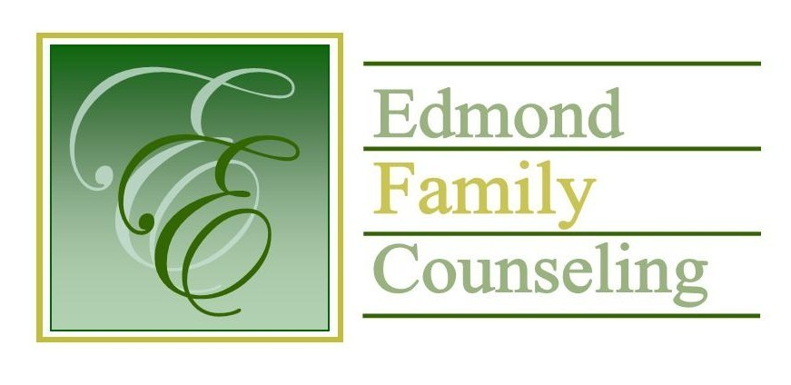
Edmond Family Counseling is committed to strengthening families and our community by championing mental health through prevention, education, and counseling.

November Meeting Agenda
MEETING DATE: November 26, 2019 12:00 to 1:00 pm
Therapist Showcase- John Goetz, LPC

1. Call to Order: President- Chris Budde

2. Consent Agenda: Remember anything in this section can be removed, discussed and voted on separately.
a. October Meeting Minutes
b. October Director’s Report (Summary of Director’s activities since last board mtg.)
c. October Assistant Director’s Report (Summary of Assistant Director’s activities since last board mtg.)
d. October Statistical Report

3. Old Business
a. Update on building renovations

4. New Business
a. Possible consideration and vote to enter executive session to discuss budget changes related to possible employee hiring
b. Possible consideration and vote to enter regular board session
c. Possible consideration and vote on any motions as a result of executive session
d. Update on CARF
e. Possible consideration and vote to approve financial audit
f. Possible consideration and vote to approve employee health insurance plan for 2020

5. Board Resources – Sheila Stinnett
a. Update on agency Christmas Party
b. List of board meetings for calendar year 2020

Legislative focus of the month- Kathy Matthews

6. Committee Reports:
a. Financial Committee
- October Treasurer’s Report
- Update on Boulevard contract
b. Hope for Families – Chris Budde
c. Fundraising- Sheila Stinnett
d. Public Relations and Be Edmond- Sheila Stinnett
e. Professional Development & Oversight Committee- Bill Hesse

7. New Business- (In accordance with the Open Meeting Act, new business is defined as any matter not known about or which could not have been reasonably foreseen prior to the time of posting the agenda.)

8. Adjournment

Mary Johnston will be providing lunch for November 2019.
Please call 341-3554 & leave a message if you are unable to attend
EFC Board Meeting agenda posted in the EFC lobby November 22, 2019

