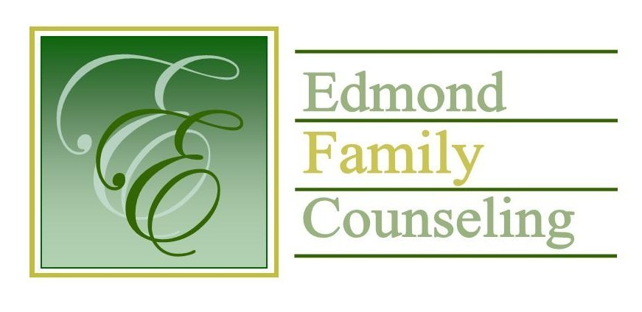
Edmond Family Counseling is committed to strengthening families and our community by championing mental health through prevention, education, and counseling.

November Meeting Agenda
MEETING DATE: November 27, 2018 12:00 to 1:00 pm
Therapist Showcase- Audrey Woods, LPC candidate

1. Call to Order: President- Tim Bridges

2. Consent Agenda: Remember anything in this section can be removed, discussed and voted on separately.
a. October Meeting Minutes
b. October Director’s Report (Summary of Director’s activities since last board mtg.)
c. October Assistant Director’s Report (Summary of Assistant Director’s activities since last board mtg.)
d. October Treasurer’s Report
e. October Statistical Report

3. Old Business- None

4. New Business
a. Possible consideration and vote to approve changes to policy and procedure as recommended by EFC’s external financial auditor, Kim Mayer.

5. Board Resources – Sheila Stinnett
a. Center for Non-Profits Board Training Opportunities
b. Discussion about Christmas party
c. List of board meetings for calendar year 2019

Legislative focus of the month- Chuck De Bellevue

6. Committee Reports:
a. Hope for Families – Bill Hesse- Discussion, appointment, and possible vote to replace HFF board members with term ending in Jan 2019
b. Fundraising- Sheila Stinnett
c. Public Relations and Be Edmond- Justice Hernandez
d. Professional Development & Oversight Committee – Jay Parks

7. New Business- (In accordance with the Open Meeting Act, new business is defined as any matter not known about or which could not have been reasonably foreseen prior to the time of posting the agenda.)

8. Adjournment

Aimee Yarbrough will be providing lunch for November 2018.
Please call 341-3554 & leave a message if you are unable to attend
EFC Board Meeting agenda posted in the EFC lobby November 20, 2018

