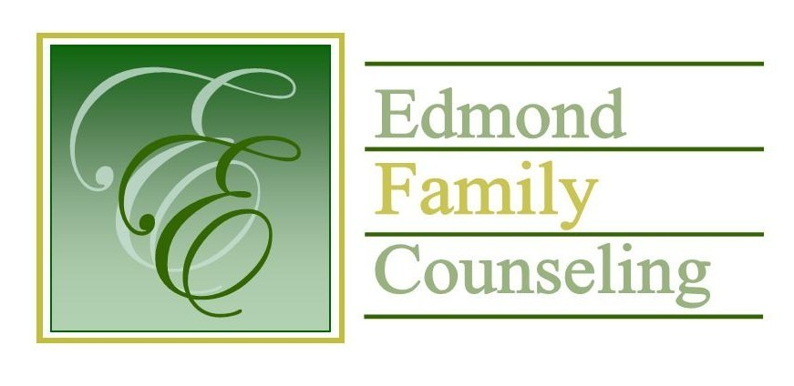
Edmond Family Counseling is committed to strengthening families and our community by championing mental health through prevention, education, and counseling.

May Meeting Agenda
MEETING DATE: May 28, 2019 12:00 to 1:00 pm
Therapist Showcase- Chad McCoy, LPC

1. Call to Order: Vice President- Chris Budde

2. Introduction of Guest- Jessica Hunt

3. Consent Agenda: Remember anything in this section can be removed, discussed and voted on separately.
a. April Meeting Minutes
b. April Director’s Report (Summary of Director’s activities since last board mtg.)
c. April Assistant Director’s Report (Summary of Assistant Director’s activities since last board mtg.)
d. April Statistical Report

4. Old Business
a. Discussion and vote to approve WSI bid

5. New Business
a. Set date for FY’19 budget meeting
b. Discussion about purchase of agency flooring
c. Update on FY’19 strategic plan
d. Update on French Family Foundation grant meeting
e. Discussion on expansion of OJA contract to cover elementary small group services
f. Update on City of Edmond CARC grant

6. Board Resources – Sheila Stinnett
a. Center for Non-Profits Training
b. Reminder of Executive Director’s upcoming evaluation

Legislative focus of the month- Kathy Matthews

7. Committee Reports:
a. Financial Committee
- April Treasurer’s Report
- Update on contracts and agency budget
b. Hope for Families – Chris Budde
c. Fundraising- Sheila Stinnett- Discussion about matching funds to expand elementary group services
d. Public Relations and Be Edmond- Sheila Stinnett
- Update on Mental Health Advisory Council
- Update on Newcomer’s Guide
e. Professional Development & Oversight Committee- Chris Budde

8. New Business- (In accordance with the Open Meeting Act, new business is defined as any matter not known about or which could not have been reasonably foreseen prior to the time of posting the agenda.)

9. Adjournment

Kenny Yarbrough will be providing lunch for May 2019.
Please call 341-3554 & leave a message if you are unable to attend
EFC Board Meeting agenda posted in the EFC lobby May 23, 2019

