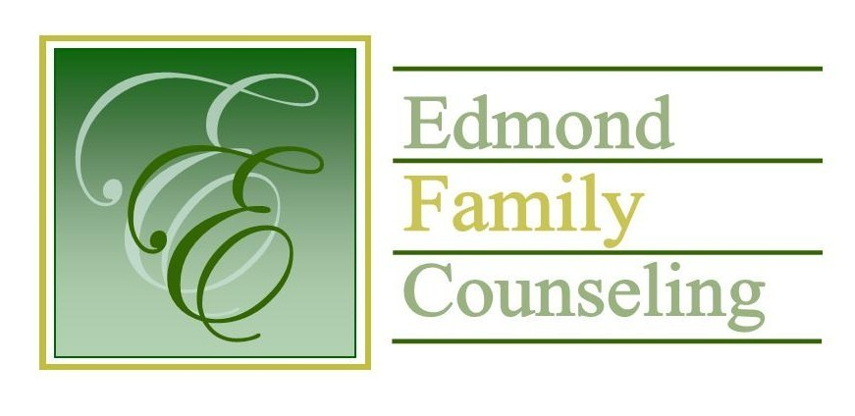
Edmond Family Counseling is committed to strengthening families and our community by championing mental health through prevention, education, and counseling.

June Meeting Agenda
MEETING DATE: June 29, 2021 12:00 to 1:00 pm
Therapist Showcase- Sheila Stinnett

1. Call to Order: President- Chris Budde

2. Consent Agenda: Remember anything in this section can be removed, discussed and voted on separately.
a. May Meeting Minutes
b. May Special Meeting Minutes
c. June Director’s Report (Summary of Director’s activities since last board mtg.)
d. June Administrative Manager’s Report (Summary of Administrative Manager’s activities since last board mtg.)
e. May Statistical Report

3. Old Business
a. Possible consideration and vote to revise EFC board bylaws
b. Possible consideration and vote to approve Suhani Lageman’s resignation
c. Discussion and vote on revision of employee leave policy as per recommendation by agency’s legal counsel
d. Discussion and update on Girl Strong program

4. New Business
a. Possible consideration and vote to enter executive session as per title 25 Oklahoma statute 307 (b)(1)
b. Possible consideration and vote to enter regular board session
c. Possible consideration and vote on any motions as a result of executive session
d. Possible consideration and vote to approve FY’22 Strategic Action Plan
e. Discussion concerning 2021 OAYS Peer Review
f. Discussion on French Family Foundation grant funds for FY’22
g. Possible consideration and vote to approve procedures of the business continuity/recovery plan

5. Board Resources – Sheila Stinnett
- Appointment of board nomination committee
- Discussion to schedule annual board meeting

Legislative focus of the month- Kathy Matthews

6. Committee Reports:
a. Financial Committee
- May Treasurer’s Report
- Possible consideration and vote to designate the BancFirst account for employee salary reserve
b. Hope for Families – Chris Budde
c. Fundraising- Sheila Stinnett
d. Public Relations and Be Edmond- Sheila Stinnett
e. Professional Development & Oversight Committee- Sarah Brown

7. New Business- (In accordance with the Open Meeting Act, new business is defined as any matter not known about or which could not have been reasonably foreseen prior to the time of posting the agenda.)

8. Adjournment

Lunch will be provided by EFC for June 2021
Please call 341-3554 & leave a message if you are unable to attend
EFC Board Meeting agenda posted in the EFC lobby June 25, 2021

