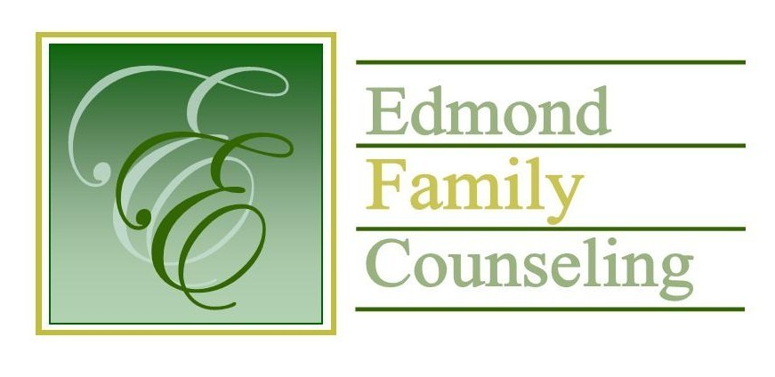
Edmond Family Counseling is committed to strengthening families and our community by championing mental health through prevention, education, and counseling.

July Meeting Agenda
MEETING DATE: July 27, 2021 12:00 to 1:00 pm
Therapist Showcase- Colin Turpin

1. Call to Order: President- Chris Budde

2. Consent Agenda: Remember anything in this section can be removed, discussed and voted on separately.
a. June Meeting Minutes
b. June Director’s Report (Summary of Director’s activities since last board mtg.)
c. June Administrative Manager’s Report (Summary of Administrative Manager’s activities since last board mtg.)
d. June Statistical Report
e. Quarterly Reports for 4th Qtr of FY’21

3. Old Business
a. Report on possible changes to agency’s COVID-19 protocols

4. New Business
a. Possible consideration and vote to approve bid from Kim Mayer and Kristi Dobbins for FY’21 external financial audit
b. Discussion and possible vote to approve FY’22 contract extension from OJA
c. Discussion on upcoming planning meeting with Edmond Juvenile Court
d. Possible consideration and vote to approve slate of officers for FY’22
e. Update on Girl Strong funding from OJA
f. Possible consideration and vote to move policy and procedure review and revision to September board meeting
g. Possible consideration and vote to approve additional $6,400 contract with EPS Special Services for FY’22

5. Board Resources – Sheila Stinnett
- Annual meeting date reminder
- Discussion on board recruitment

Legislative focus of the month- Kathy Matthews

6. Committee Reports:
a. Financial Committee
- June Treasurer’s Report
b. Hope for Families – Chris Budde
c. Fundraising- Sheila Stinnett- Schedule committee meeting
d. Public Relations and Be Edmond- Sheila Stinnett
e. Professional Development & Oversight Committee- Sarah Brown

7. New Business- (In accordance with the Open Meeting Act, new business is defined as any matter not known about or which could not have been reasonably foreseen prior to the time of posting the agenda.)

8. Adjournment

Lunch will be provided by EFC for July 2021
Please call 341-3554 & leave a message if you are unable to attend
EFC Board Meeting agenda posted in the EFC lobby July 22, 2021

