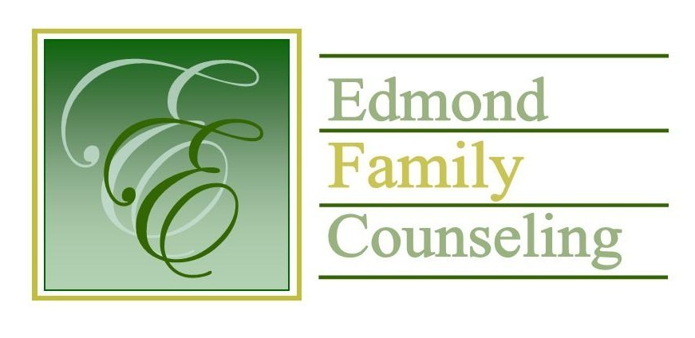
Edmond Family Counseling is committed to strengthening families and our community by championing mental health through prevention, education, and counseling.

October Meeting Agenda
MEETING DATE: October 26, 2021 12:00 to 1:00 pm

1. Call to Order: President- Tim Bridges

2. Introduction of Guests

3. Consent Agenda: Remember anything in this section can be removed, discussed and voted on separately.
a. September Meeting Minutes
b. October Director’s Report (Summary of Director’s activities since last board mtg.)
c. October Administrative Manager’s Report (Summary of Administrative Manager’s activities since last board mtg.)
d. September Statistical Report
e. Quarterly Reports for 1st Qtr. FY’22

4. Old Business- None

5. New Business
a. Discussion on employee health and dental insurance for 2022
b. Discussion and review of agency participation in the Community Action for Targeted Solutions plan
c. Discussion on additional payout of FY’21 funding from the Office of Juvenile Affairs
d. Discussion and approval of revised revenue budget
e. Discussion on OAYS proposal for the distribution of legislative awarded additional funding for FY’22

6. Board Resources – Sheila Stinnett
- Discussion on board Christmas party

Legislative focus of the month- Kathy Matthews

7. Committee Reports:
a. Financial Committee
- Possible consideration and vote to approve September 2021 Treasurer’s Report
- Progress on Edmond Public Schools Special Services training contract
b. Hope for Families
c. Fundraising- Sheila Stinnett
d. Public Relations and Be Edmond- Sheila Stinnett
e. Professional Development & Oversight Committee- Sarah Brown

8. New Business- (In accordance with the Open Meeting Act, new business is defined as any matter not known about or which could not have been reasonably foreseen prior to the time of posting the agenda.)

9. Adjournment

Lunch will be provided by EFC for October 2021
Please call 341-3554 & leave a message if you are unable to attend
EFC Board Meeting agenda posted in the EFC lobby October 22, 2021

