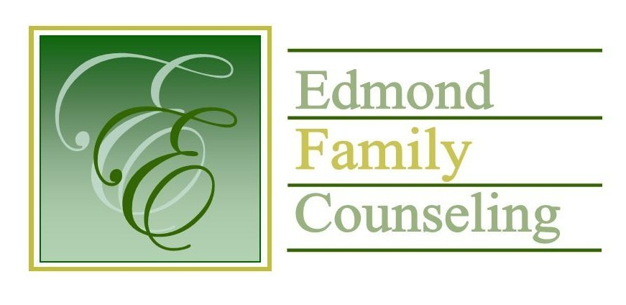
Edmond Family Counseling is committed to strengthening families and our community by championing mental health through prevention, education, and counseling.

November Meeting Agenda
MEETING DATE: November 30, 2021 12:00 to 1:00 pm
Therapist Showcase: John Goetz, LPC

1. Call to Order: President- Tim Bridges

2. Consent Agenda: Remember anything in this section can be removed, discussed and voted on separately.
a. October Meeting Minutes
b. November Director’s Report (Summary of Director’s activities since last board mtg.)
c. November Administrative Manager’s Report (Summary of Administrative Manager’s activities since last board mtg.)
d. October Statistical Report

3. Old Business
a. Possible consideration and vote to approve employee health and dental insurance for 2022

4. New Business
a. Update on French Family Foundation grant proposal
b. Discussion on Office of Juvenile Affairs and Oklahoma Department of Mental Health and Substance Abuse Services grant awarded Botvin materials
c. Update on OAYS peer review

5. Board Resources – Sheila Stinnett
- Possible consideration and vote to approve new EFC board members
- Reminder of EFC board and staff Christmas party to be held at EFC on Dec. 10th at noon
- Discussion on end of year giving

Legislative focus of the month- Kathy Matthews

6. Committee Reports:
a. Financial Committee
- Possible consideration and vote to approve October 2021 Treasurer’s Report
- Update on additional $1.5 million in legislative funding to youth service agencies
- Update on CARC grant
b. Hope for Families
c. Fundraising- Sheila Stinnett
d. Public Relations and Be Edmond- Sheila Stinnett
e. Professional Development & Oversight Committee- Sarah Brown

7. New Business- (In accordance with the Open Meeting Act, new business is defined as any matter not known about or which could not have been reasonably foreseen prior to the time of posting the agenda.)

8. Adjournment

Lunch will be provided by EFC for November 2021
Please call 341-3554 & leave a message if you are unable to attend
EFC Board Meeting agenda posted in the EFC lobby November 23, 2021

