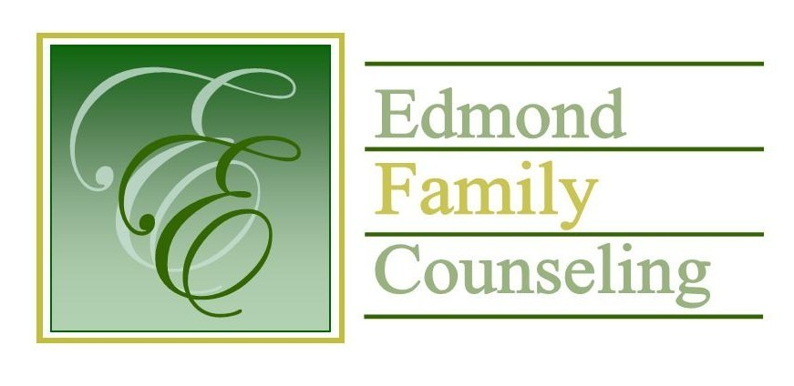
Edmond Family Counseling is committed to strengthening families and our community by championing mental health through prevention, education, and counseling.

November Meeting Agenda
MEETING DATE: November 29th, 2022 12:00 to 1:00 pm
Therapist Showcase- Jaira Draper

1. Call to Order: President- Kathy Matthews

2. Consent Agenda: Remember anything in this section can be removed, discussed and voted on separately.
a. October Meeting Minutes
b. November Director’s Report (Summary of Director’s activities since last board mtg.)
c. November Administrative Manager’s Report (Summary of Administrative Manager’s activities since last board mtg.)
d. October Statistical Report
e. November Public Relations Coordinator’s Report

3. Old Business
a. Possible consideration and vote to approve employee health and dental insurance for 2023

4. New Business
a. Discuss OJA payment of FY 22 contract overage
b. Possible consideration and vote to enter executive session to discuss employee pay scales
c. Possible consideration and vote to enter regular board session
d. Possible consideration and vote on any motions as a result of executive session
e. Possible consideration and vote to approve bid for LED lighting
f. Announcement of CARF dates
g. Discussion on security updates for the lobby

5. Board Resources – Sheila Stinnett
- Discussion on board Christmas party
- Discussion on end of year giving
- Discussion on Microsoft Teams

Legislative focus of the month- Kathy Matthews

6. Committee Reports:
a. Financial Committee
- Possible consideration and vote to approve October 2022 Treasurer’s Report
b. Hope for Families
c. Fundraising- Sheila Stinnett
d. Public Relations and Be Edmond- Katie Golden
e. Professional Development & Oversight Committee- Sarah Brown

7. New Business- (In accordance with the Open Meeting Act, new business is defined as any matter not known about or which could not have been reasonably foreseen prior to the time of posting the agenda.)

8. Adjournment

Lunch will be provided by EFC for November 2022
Please call 341-3554 & leave a message if you are unable to attend
EFC Board Meeting agenda posted in the EFC lobby November 22, 2022
EFC participates in Amazon Smiles

