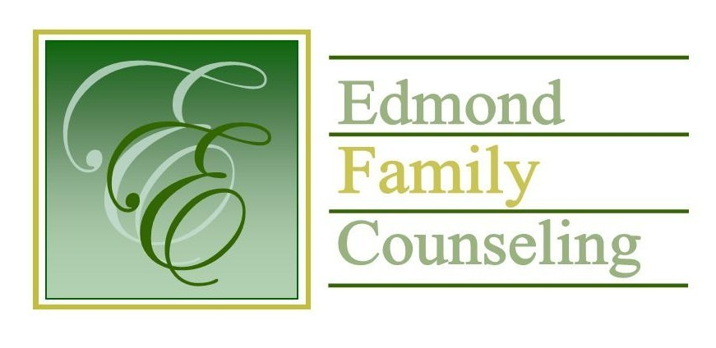
Edmond Family Counseling is committed to strengthening families and our community by championing mental health through prevention, education, and counseling.

May Meeting Agenda
MEETING DATE: May 31st, 2022 12:00 to 1:00 pm
Therapist Showcase: John Goetz, LPC

1. Call to Order: President- Tim Bridges

2. Consent Agenda: Remember anything in this section can be removed, discussed and voted on separately.
a. April Meeting Minutes
b. May Director’s Report (Summary of Director’s activities since last board mtg.)
c. May Administrative Manager’s Report (Summary of Administrative Manager’s activities since last board mtg.)
d. April Statistical Report

3. Old Business
a. Update on board portal information

4. New Business
a. Possible consideration and vote to approve adding Lisa Trent to the EFC board
b. Possible consideration and vote to approve FY’23 Sliding Fee Scale
c. Possible consideration and vote to approve mileage reimbursement rate for FY’23
d. Report on employee survey
e. Possible consideration and vote to approve non-solicitation policy
f. Update on agency external financial auditor

5. Board Resources – Sheila Stinnett
- Schedule FY’23 budget meeting
- Schedule strategic action plan committee meeting
- Appointment of board nomination committee

Legislative focus of the month- Kathy Matthews

6. Committee Reports:
a. Financial Committee
- Possible consideration and vote to approve April 2022 Treasurer’s Report
b. Hope for Families
c. Fundraising- Sheila Stinnett- Community Chat Update
d. Public Relations and Be Edmond- Sheila Stinnett- Discussion about Summer 2022 GirlStrong program
e. Professional Development & Oversight Committee- Sarah Brown

7. New Business- (In accordance with the Open Meeting Act, new business is defined as any matter not known about or which could not have been reasonably foreseen prior to the time of posting the agenda.)

8. Adjournment

Lunch will be provided by EFC for May 2022
Please call 341-3554 & leave a message if you are unable to attend
EFC Board Meeting agenda posted in the EFC lobby May 26, 2022
EFC participates in Amazon Smiles

