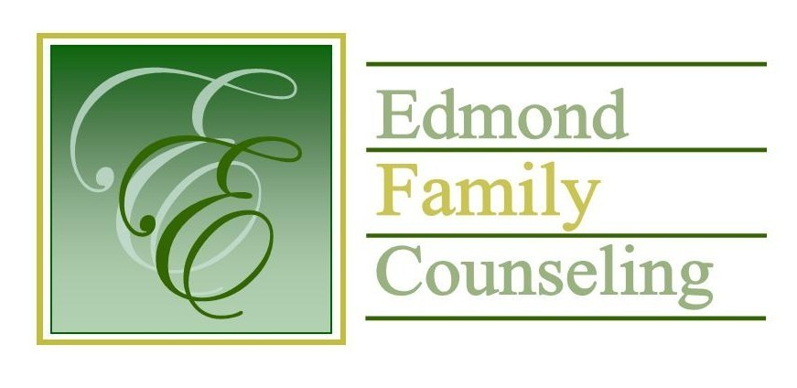
Edmond Family Counseling is committed to strengthening families and our community by championing mental health through prevention, education, and counseling.

March Meeting Agenda
MEETING DATE: March 29, 2022 12:00 to 1:00 pm
Therapist Showcase: Jamie Prisco-Rudolph, LPC

1. Call to Order: President- Tim Bridges

2. Consent Agenda: Remember anything in this section can be removed, discussed and voted on separately.
a. February Meeting Minutes
b. March Director’s Report (Summary of Director’s activities since last board mtg.)
c. March Administrative Manager’s Report (Summary of Administrative Manager’s activities since last board mtg.)
d. February Statistical Report

3. Old Business- None

4. New Business
a. Discussion on board portal
b. Discussion concerning agency visit with Edmond Police Chief, J.D. Younger
c. Possible consideration and approval of FY’23 Special Services contract

5. Board Resources – Sheila Stinnett
- Discussion of FY’23 strategic planning committee assignments

Legislative focus of the month- Kathy Matthews

6. Committee Reports:
a. Financial Committee
- Possible consideration and vote to approve February 2022 Treasurer’s Report
b. Hope for Families
c. Fundraising- Sheila Stinnett- Community Chat Update
d. Public Relations and Be Edmond- Sheila Stinnett
e. Professional Development & Oversight Committee- Sarah Brown

7. New Business- (In accordance with the Open Meeting Act, new business is defined as any matter not known about or which could not have been reasonably foreseen prior to the time of posting the agenda.)

8. Adjournment

Lunch will be provided by EFC for March 2022
Please call 341-3554 & leave a message if you are unable to attend
EFC Board Meeting agenda posted in the EFC lobby March 25, 2022

