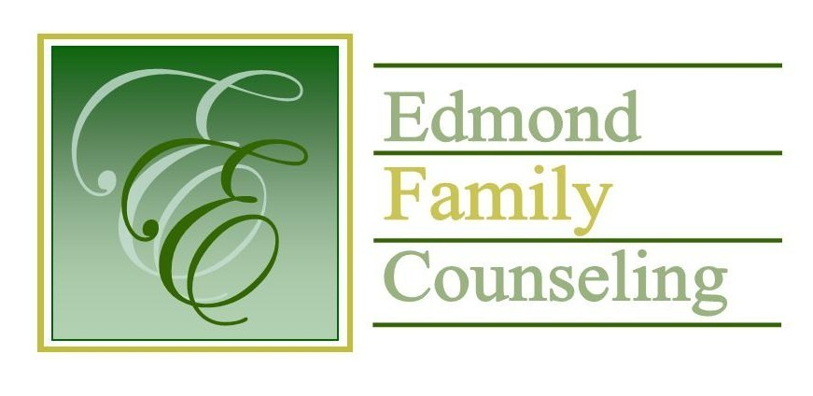
Edmond Family Counseling is committed to strengthening families and our community by championing mental health through prevention, education, and counseling.

June Meeting Agenda
MEETING DATE: June 28th, 2022 12:00 to 1:00 pm
Therapist Showcase: Sheila Stinnett, LPC

1. Call to Order: President- Tim Bridges

2. Consent Agenda: Remember anything in this section can be removed, discussed and voted on separately.
a. May Meeting Minutes
b. June Special Meeting Minutes
c. June Director’s Report (Summary of Director’s activities since last board mtg.)
d. June Administrative Manager’s Report (Summary of Administrative Manager’s activities since last board mtg.)
e. May Statistical Report

3. Old Business
a. Schedule with Bob Peterson to discuss board portal
b. Possible consideration and vote to approve agency external financial auditor

4. New Business
a. Possible consideration and vote to enter executive session to discuss personnel as per title 25 Oklahoma statute 307 (b)(1)
b. Possible consideration and vote to enter regular session
c. Possible consideration and vote on any motions as a result of executive session
d. Possible consideration and vote to approve job description for part time marketing position
e. Possible consideration and vote to approve FY’23 strategic action plan
f. Possible consideration and vote to approve leasing a safe deposit box

5. Board Resources – Sheila Stinnett
- Reminder of slate of officers for July board meeting
- Possible consideration and vote to approve Hope for Families board representation

Legislative focus of the month- Kathy Matthews

6. Committee Reports:
a. Financial Committee
- Possible consideration and vote to approve May 2022 Treasurer’s Report
b. Hope for Families
c. Fundraising- Sheila Stinnett
d. Public Relations and Be Edmond- Sheila Stinnett
e. Professional Development & Oversight Committee- Sarah Brown

7. New Business- (In accordance with the Open Meeting Act, new business is defined as any matter not known about or which could not have been reasonably foreseen prior to the time of posting the agenda.)

8. Adjournment

Lunch will be provided by EFC for June 2022
Please call 341-3554 & leave a message if you are unable to attend
EFC Board Meeting agenda posted in the EFC lobby June 23, 2022
EFC participates in Amazon Smiles

