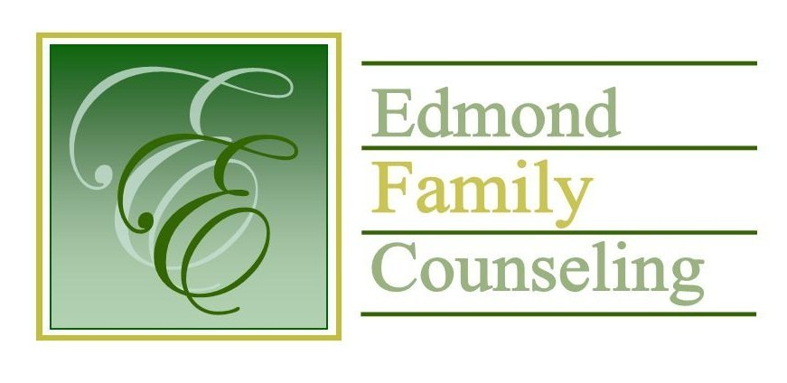
Edmond Family Counseling is committed to strengthening families and our community by championing mental health through prevention, education, and counseling.

July Meeting Agenda
MEETING DATE: July 26th, 2022 12:00 to 1:00 pm
Therapist Showcase: Sheila Stinnett, LPC

1. Call to Order: President- Tim Bridges

2. Consent Agenda: Remember anything in this section can be removed, discussed and voted on separately.
a. June Meeting Minutes
b. July Director’s Report (Summary of Director’s activities since last board mtg.)
c. July Administrative Manager’s Report (Summary of Administrative Manager’s activities since last board mtg.)
d. June Statistical Report
e. Public Relations Coordinator’s Report
f. Quarterly Reports for 4th Quarter of FY 2022

3. Old Business
a. Reminder of zoom meeting with Bob Peterson on Friday, July 29th at 11:00 am to
to discuss board portal
b. Update on agency external financial auditor
c. Possible consideration and vote to approve leasing a safety deposit box from Citizens Bank

4. New Business
a. Possible consideration and vote to approve adding Chelsea Bradshaw to the EFC board
b. Possible consideration and vote to approve OJA contract revisions
c. Possible consideration and vote to approve revisions to the FY 2023 revenue and operational budget
d. Possible consideration and vote to approve FY 2023 CARC contract and MOU with Edmond Juvenile Court
e. Possible consideration and vote to approve FY 2023 contract with Boulevard Academy

5. Board Resources – Sheila Stinnett
- Presentation and vote to approve FY’23 EFC board slate of officers
- Reminder of annual board meeting

Legislative focus of the month- Kathy Matthews

6. Committee Reports:
a. Financial Committee
- Possible consideration and vote to approve June 2022 Treasurer’s Report
b. Hope for Families
c. Fundraising- Sheila Stinnett
d. Public Relations and Be Edmond- Sheila Stinnett
e. Professional Development & Oversight Committee- Sarah Brown

7. New Business- (In accordance with the Open Meeting Act, new business is defined as any matter not known about or which could not have been reasonably foreseen prior to the time of posting the agenda.)

8. Adjournment

Lunch will be provided by EFC for July 2022
Please call 341-3554 & leave a message if you are unable to attend
EFC Board Meeting agenda posted in the EFC lobby July 22, 2022
EFC participates in Amazon Smiles

