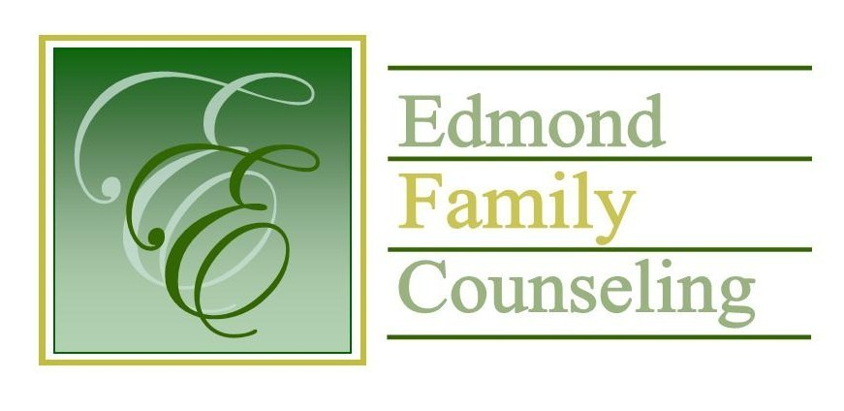
Edmond Family Counseling is committed to strengthening families and our community by championing mental health through prevention, education, and counseling.

January Meeting Agenda
MEETING DATE: January 25, 2022 12:00 to 1:00 pm
Therapist Showcase: None

1. Call to Order: President- Tim Bridges

2. Consent Agenda: Remember anything in this section can be removed, discussed and voted on separately.
a. November Meeting Minutes
b. December Special Meeting Minutes
c. December Director’s Report (Summary of Director’s activities since last board mtg.)
d. December Administrative Manager’s Report (Summary of Administrative Manager’s activities since last board mtg.)
e. November/December Statistical Report
f. Quarterly Reports for 2nd Quarter of FY 2022

3. Old Business- None

4. New Business
a. Possible consideration and vote to approve directors & officers and general, property, & liability insurance
b. Notification that the annual ACQR was submitted to CARF

5. Board Resources – Sheila Stinnett

Legislative focus of the month- Kathy Matthews

6. Committee Reports:
a. Financial Committee
- Possible consideration and vote to approve December 2021 Treasurer’s Report
- Possible consideration and vote to approve FY’21 external financial audit

b. Hope for Families
c. Fundraising- Sheila Stinnett
d. Public Relations and Be Edmond- Sheila Stinnett
e. Professional Development & Oversight Committee- Sarah Brown

7. New Business- (In accordance with the Open Meeting Act, new business is defined as any matter not known about or which could not have been reasonably foreseen prior to the time of posting the agenda.)

8. Adjournment

Lunch will be provided by EFC for January 2022
Please call 341-3554 & leave a message if you are unable to attend
EFC Board Meeting agenda posted in the EFC lobby January 20, 2022

