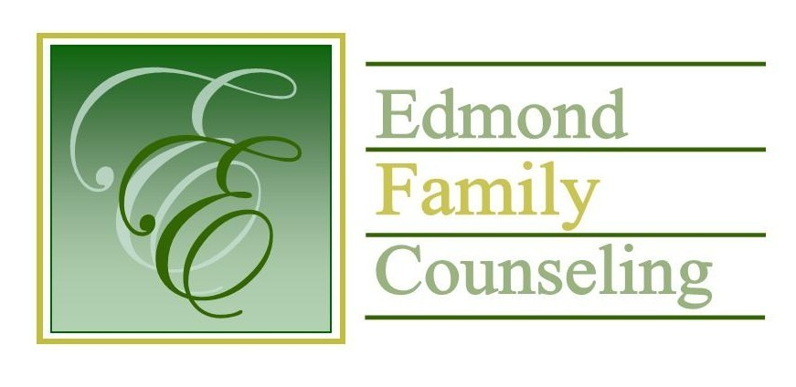
Edmond Family Counseling is committed to strengthening families and our community by championing mental health through prevention, education, and counseling.

February Meeting Agenda
MEETING DATE: February 28th, 2023 12:00 to 1:00 pm
Therapist Showcase- None

1. Call to Order: President- Kathy Matthews

2. Introduction of Guests
- Barbara Henry, CPA- External Financial Auditor

3. Consent Agenda: Remember anything in this section can be removed, discussed and voted on separately.
a. November Meeting Minutes
b. January Special Meeting Minutes
c. January Director’s Report (Summary of Director’s activities since last board mtg.)
d. February Director’s Report
e. January Administrative Manager’s Report (Summary of Administrative Manager’s activities since last board mtg.)
f. February Administrative Manager's Report
g. November/December Statistical Report
h. January Statistical Report
i. January Public Relations Coordinator’s Report
j. February Public Relations Coordinator’s Report
k. Quarterly Reports for 2nd Qtr. of FY’23

4. Old Business- None

5. New Business
a. Possible consideration and vote to approve FY’22 external financial audit
b. Update on agency response in community crisis situations
c. Update on CARF certification
d. Possible consideration and vote to approve revised LED lighting proposal from Voss Lighting
e. Possible consideration and vote to approve Edmond Character Council proposal
f. Discussion on CARC grant proposal
g. Possible consideration and vote to approve OAYS peer review
h. Possible consideration and vote to approve purchase of new group room chairs
i. Discussion about FY’24 strategic planning
j. Update on status of OAYS/OJA relationship

6. Board Resources – Sheila Stinnett

Legislative focus of the month- Kathy Matthews

7. Committee Reports:
a. Financial Committee
- Possible consideration and vote to approve January 2023 Treasurer’s Report
- Possible consideration and vote to approve purchase of certificate of deposit
b. Hope for Families
- Possible consideration and vote to replace Mary Johnston on the HFF committee due to maternity leave
- Discussion on plumbing issue
c. Fundraising- Katie Golden
- Community Chat update
d. Public Relations and Be Edmond- Katie Golden
e. Professional Development & Oversight Committee- Sarah Brown

8. New Business- (In accordance with the Open Meeting Act, new business is defined as any matter not known about or which could not have been reasonably foreseen prior to the time of posting the agenda.)

9. Adjournment

Lunch will be provided by EFC for February 2024
Please call 341-3554 & leave a message if you are unable to attend
EFC Board Meeting agenda posted in the EFC lobby February 24, 2023
EFC participates in Amazon Smiles

