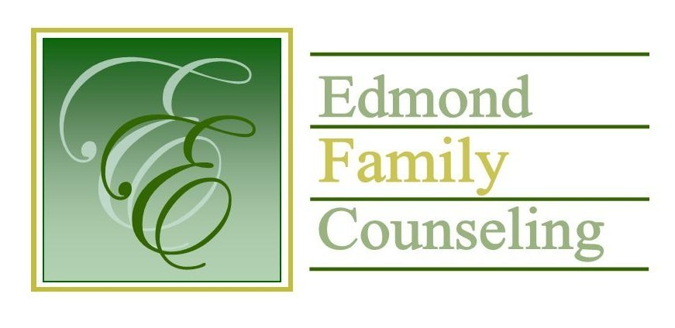
Edmond Family Counseling is committed to strengthening families and our community by championing mental health through prevention, education, and counseling.

February Meeting Agenda
MEETING DATE: February 22, 2022 12:00 to 1:00 pm
Therapist Showcase: Sheila Stinnett

1. Call to Order: President- Tim Bridges

2. Consent Agenda: Remember anything in this section can be removed, discussed and voted on separately.
a. January Meeting Minutes
b. February Director’s Report (Summary of Director’s activities since last board mtg.)
c. February Administrative Manager’s Report (Summary of Administrative Manager’s activities since last board mtg.)
d. January Statistical Report

3. Old Business- None

4. New Business
a. Possible consideration and vote to enter executive session to discuss personnel matters as per title 25 Oklahoma statute 307 (b)(2)
b. Possible consideration and vote to enter regular board session
c. Possible consideration and vote on any motions as a result of executive session
d. Discussion about FY’23 strategic planning
e. Possible consideration and vote to approve Lynn Reese as the primary administrator of Intuit QuickBooks
f. Discussion over CARC presentation

5. Board Resources – Sheila Stinnett
- Community Chat Update

Legislative focus of the month- Kathy Matthews

6. Committee Reports:
a. Financial Committee
- Possible consideration and vote to approve January 2022 Treasurer’s Report
b. Hope for Families
c. Fundraising- Sheila Stinnett
d. Public Relations and Be Edmond- Sheila Stinnett
e. Professional Development & Oversight Committee- Sarah Brown

7. New Business- (In accordance with the Open Meeting Act, new business is defined as any matter not known about or which could not have been reasonably foreseen prior to the time of posting the agenda.)

8. Adjournment

Lunch will be provided by EFC for February 2022
Please call 341-3554 & leave a message if you are unable to attend
EFC Board Meeting agenda posted in the EFC lobby February 18, 2022

