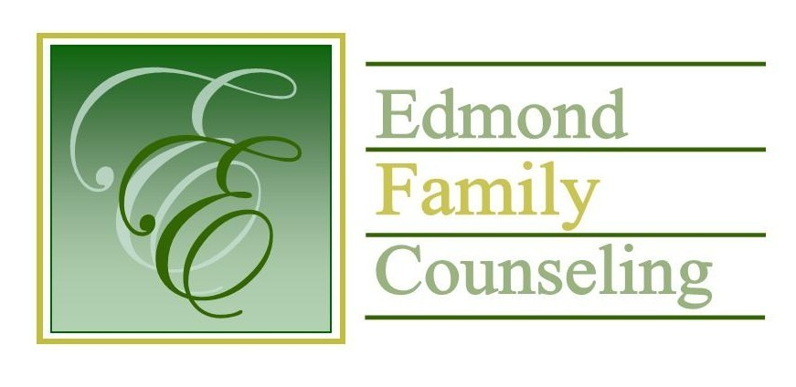
Edmond Family Counseling is committed to strengthening families and our community by championing mental health through prevention, education, and counseling.

April Meeting Agenda
MEETING DATE: April 26th, 2022 12:00 to 1:00 pm
Therapist Showcase: Lisa Kadavy

1. Call to Order: President- Tim Bridges

2. Introduction of Guests

3. Consent Agenda: Remember anything in this section can be removed, discussed and voted on separately.
a. March Meeting Minutes
b. April Director’s Report (Summary of Director’s activities since last board mtg.)
c. April Administrative Manager’s Report (Summary of Administrative Manager’s activities since last board mtg.)
d. March Statistical Report
e. Quarterly Reports for 3rd Qtr. of FY’22

4. Old Business
a. Reminder of strategic planning meeting

5. New Business
a. Discussion on visit from the Office of Juvenile Affairs
b. Discussion on plumbing issue
c. Possible consideration and vote to continue the agency’s CARF accreditation
d. Discussion on board portal

6. Board Resources – Sheila Stinnett
- Reminder of Executive Director’s upcoming evaluation

Legislative focus of the month- Kathy Matthews

7. Committee Reports:
a. Financial Committee
- Possible consideration and vote to approve March 2022 Treasurer’s Report
b. Hope for Families
c. Fundraising- Sheila Stinnett- Community Chat Update
d. Public Relations and Be Edmond- Sheila Stinnett
e. Professional Development & Oversight Committee- Sarah Brown

8. New Business- (In accordance with the Open Meeting Act, new business is defined as any matter not known about or which could not have been reasonably foreseen prior to the time of posting the agenda.)

9. Adjournment

Lunch will be provided by EFC for April 2022
Please call 341-3554 & leave a message if you are unable to attend
EFC Board Meeting agenda posted in the EFC lobby May 25, 2022
EFC participates in Amazon Smiles

