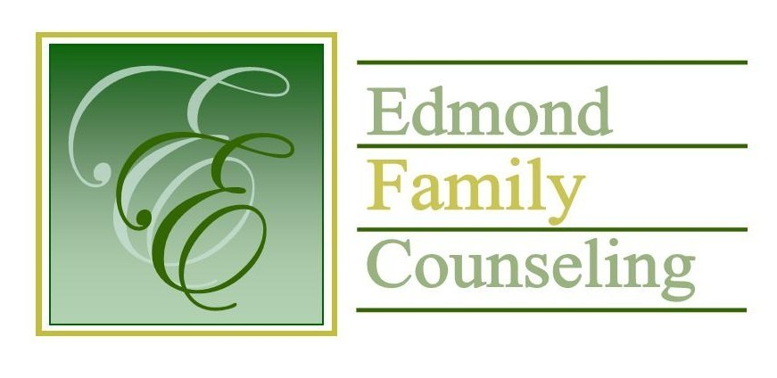

**Edmond Family Counseling is committed to strengthening families and our community by championing mental health through prevention, education, and counseling.**

**July Meeting Agenda**

MEETING DATE: **July 30, 2024 12:00 to 1:00 pm**

Therapist Showcase- TBD

1. Call to Order: President- Kathy Matthews

2. **Consent Agenda:** Remember anything in this section can be removed, discussed and voted on separately.

a. June Meeting Minutes

b. July Director’s Report (Summary of Director’s activities since last board mtg.)

c. July Administrative Manager’s Report (Summary of Administrative Manager’s activities since last board mtg.)

d. June Statistical Report

e. July Public Relations Coordinator’s Report

f. July Finance Committee Meeting Minutes

g. Quarterly Reports for 4th Qtr of FY 2024

3. Old Business

a. Possible consideration and vote to approve FY’25 slate of officers

4. New Business

a. Possible consideration and vote to enter executive session to discuss personnel issue

b. Possible consideration and vote to enter regular board session

c. Possible consideration and vote on any motions as a result of executive session

d. Possible consideration and vote to approve FY’25 OAYS contract

e. Update on FY’24 Office of Juvenile Affairs contract overage

f. Update on bid from Nominee

g. Discussion of potential MOU with Edmond Public Schools for 3rd and 5th grade groups

h. Update on FY’25 Edmond Municipal Court services

i. Update on opioid grant

5. Board Resources – Sheila Stinnett

a. Reminder of annual board meeting on August 27th

b. Legislative focus of the month- Kathy Matthews

c. Community Liaison- Stephanie Coy

6. Committee Reports:

a. Financial Committee

* Possible consideration and vote to approve June 2024 Treasurer’s Report
* Discussion on payroll coverage deposits

b. Ad hoc Rebranding Committee

c. Ad hoc Safety Committee

d. Fundraising- Katie Golden

e. Public Relations and Be Edmond- Katie Golden

f. Hope for Families

g. Professional Development & Oversight Committee- Sarah Brown

7. New Business- (In accordance with the Open Meeting Act, new business is defined as any matter not known about or which could not have been reasonably foreseen prior to the time of posting the agenda.)

8. Adjournment

**Lunch will be provided by EFC for July 2024**

**Please call 341-3554 & leave a message if you are unable to attend**

EFC Board Meeting agenda posted in the EFC lobby July 26, 2024